COFFEE BOARD: BENGALURU
Daily Coffee Market Report Monday, April 03, 2017

Futures Prices 31.03.2017
ICE (New York)- Arabica- US cents / lb |  |  | LIFFE(London) – Robusta -US $ / tonne and cents / lb in brackets (10 MT contract)
Month | Price | Prev. Price | Month | Price | Prev. Price
May – 2017 | 139.30 | 139.30 | Mar – 2017 | 2136 (96.89) | 2136 (96.89)
July – 2017 | 141.65 | 141.70 | May – 2017 | 2149 (97.48) | 2161 (98.02)
Sep – 2017 | 144.00 | 144.05 | July – 2017 | 2171 (98.48) | 2179 (98.84)

ICO Group Indicator price on 27.03.2017 and previous price in brackets
Other Mild Arabica |  | Robusta |  |  | Exchange Rate Rs/ US $
US Cents/lb | Rs/kg | US Cents/lb | Rs/kg
158.29 (156.50) | 226.66 (224.58) | 106.87 (104.81) | 153.03 (150.40) |  | 64.84

Futures Price Trend
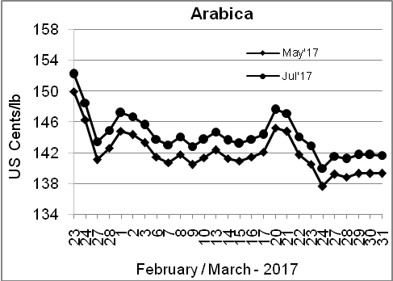
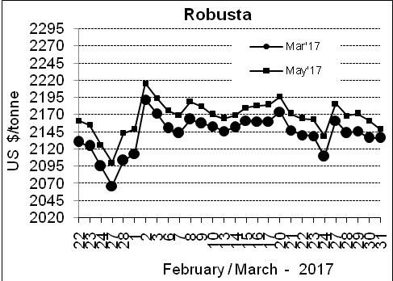

Market Analysis
ICE May arabica coffee futures finished unchanged from the previous session at $1.393 per lb, ending the quarter with a slight gain. May robusta coffee futures settled down $12, or 0.56 percent, at $2,149 per tonne. The market was monitoring weather in Brazil amid forecasts for some light crop-friendly rains in coffee regions that have been plagued by dry conditions recently.

Differentials: | Ar. Plant. A | Ar.Chy.AB | Rob.Pmt.AB | Rob.Chy.AB
Differentials: | NY +12 to +15 | NY –25 to –28 | LIFFE +525 to +550 | LIFFE +65 to +85
2

ICTA Auction Prices Rs/Kg as on 23.03.2017
Grade | MNEB | AA | PB | A | AB | B | C | BBB
Arabica Plantation | --- | --- | --- | 225.00 | --- | 205.00 | --- | ---
Arabica Cherry | --- | --- | --- | --- | --- | --- | --- | ---
 | RKR | A | PB | AA | AB | B | C | BBB
Robusta Parchment | --- | --- | --- | --- | --- | --- | --- | ---
Robusta Cherry | --- | --- | --- | --- | --- | --- | --- | ---

Raw Coffee Price (Karnataka) as on 30.03.2017 in Rs/50 kg
Ar.Pmt |  |  | Ar.Chy |  |  | Rob.Pmt |  |  | Rob.Chy
8600 | - | 8750 | 4275 | - | 4400 | 6775 | - | 6900 | 3475 | - | 3675

Export update: From 1st January 2017 to 31st March 2017 (in metric tonnes)
 | INDIAN COFFEE | Ar.Pmt | Ar.Chy | Rob.Pmt | Rob.Chy | Roasted seeds | R & G | Instant | Total
1 | Provisional exports (Indian coffee) | 11356 | 4790 | 5724 | 42113 | 13 | 71 | 9982 | 74048
2 | Provisional exports corresponding period last year | 15542 | 3648 | 6264 | 43078 | 14 | 52 | 5466 | 74064
3 | Provisional re-exports | 0 | 14 | 40 | 0 | 0 | 0 | 20300 | 20353
4 | Provisional re-exports corresponding period last year | 0 | 0 | 0 | 0 | 0 | 5 | 20779 | 20784
5 | Total provisional exports (1+3) | 11356 | 4804 | 5763 | 42113 | 13 | 71 | 30282 | 94401
6 | Total provisional exports corresponding period last year (2+4) | 15542 | 3648 | 6264 | 43078 | 14 | 57 | 26245 | 94848

Disclaimer: The Board neither guarantees the accuracy of the information nor accept any liability whatsoever for any direct or consequential loss arising from the use of this report

