COFFEE BOARD: BENGALURU
Daily Coffee Market Report Thursday, April 06, 2017

Futures Prices 05.04.2017
ICE (New York)- Arabica- US cents / lb |  |  | LIFFE(London) – Robusta -US $ / tonne and cents / lb in brackets (10 MT contract)
Month | Price | Prev. Price | Month | Price | Prev. Price
May – 2017 | 137.30 | 137.75 | May – 2017 | 2153 (97.66) | 2144 (97.25)
July – 2017 | 139.60 | 140.05 | July – 2017 | 2179 (98.84) | 2172 (98.52)
Sep – 2017 | 141.90 | 142.40 | Sep – 2017 | 2188 (99.25) | 2182 (98.97)

ICO Group Indicator price on 04.04.2017 and previous price in brackets
Other Mild Arabica |  | Robusta |  |  | Exchange Rate Rs/ US $
US Cents/lb | Rs/kg | US Cents/lb | Rs/kg
157.37 (157.38) | 225.65 (225.21) | 106.55 (106.72) | 152.78 (152.72) |  | 65.04

Futures Price Trend
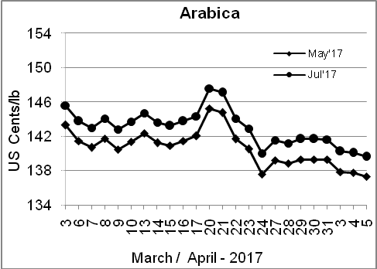
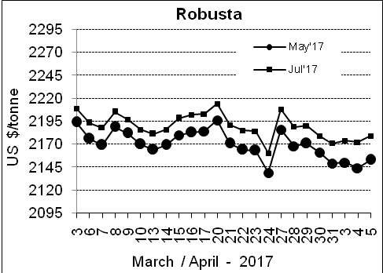

Market Analysis
ICE May arabica coffee futures finished down 0.45 cent, or 0.3 percent, at $1.373 per lb. May robusta coffee futures settled up $9 at $2,153 per tonne.

Differentials: | Ar. Plant. A | Ar.Chy.AB | Rob.Pmt.AB | Rob.Chy.AB
Differentials: | NY +12 to +15 | NY –25 to –28 | LIFFE +525 to +550 | LIFFE +65 to +85
2

ICTA Auction Prices Rs/Kg as on 23.03.2017
Grade | MNEB | AA | PB | A | AB | B | C | BBB
Arabica Plantation | --- | --- | --- | 225.00 | --- | 205.00 | --- | ---
Arabica Cherry | --- | --- | --- | --- | --- | --- | --- | ---
 | RKR | A | PB | AA | AB | B | C | BBB
Robusta Parchment | --- | --- | --- | --- | --- | --- | --- | ---
Robusta Cherry | --- | --- | --- | --- | --- | --- | --- | ---

Raw Coffee Price (Karnataka) as on 30.03.2017 in Rs/50 kg
Ar.Pmt |  |  | Ar.Chy |  |  | Rob.Pmt |  |  | Rob.Chy
8600 | - | 8750 | 4275 | - | 4400 | 6775 | - | 6900 | 3475 | - | 3675

Export update: From 1st January 2017 to 31st March 2017 (in metric tonnes)
 | INDIAN COFFEE | Ar.Pmt | Ar.Chy | Rob.Pmt | Rob.Chy | Roasted seeds | R & G | Instant | Total
1 | Provisional exports (Indian coffee) | 11356 | 4790 | 5724 | 42113 | 13 | 71 | 9960 | 74027
2 | Provisional exports corresponding period last year | 15542 | 3648 | 6264 | 43078 | 14 | 52 | 5466 | 74064
3 | Provisional re-exports | 0 | 14 | 40 | 0 | 0 | 0 | 20278 | 20331
4 | Provisional re-exports corresponding period last year | 0 | 0 | 0 | 0 | 0 | 5 | 20779 | 20784
5 | Total provisional exports (1+3) | 11356 | 4804 | 5763 | 42113 | 13 | 71 | 30238 | 94358
6 | Total provisional exports corresponding period last year (2+4) | 15542 | 3648 | 6264 | 43078 | 14 | 57 | 26245 | 94848

Disclaimer: The Board neither guarantees the accuracy of the information nor accept any liability whatsoever for any direct or consequential loss arising from the use of this report

