COFFEE BOARD: BENGALURU
Daily Coffee Market Report Friday, July 14, 2017

Futures Prices 13.07.2017
ICE (New York)- Arabica- US cents / lb |  |  | LIFFE(London) – Robusta -US $ / tonne and cents / lb in brackets (10 MT contract)
Month | Price | Prev. Price | Month | Price | Prev. Price
July – 2017 | 129.35 | 126.00 | July – 2017 | 2164 (98.16) | 2131 (96.66)
Sep – 2017 | 131.20 | 127.60 | Sep – 2017 | 2145 (97.30) | 2097 (95.12)
Dec – 2017 | 134.80 | 131.15 | Nov – 2017 | 2123 (96.30) | 2077 (94.21)

ICO Group Indicator price on 12.07.2017 and previous price in brackets
Other Mild Arabica |  | Robusta |  |  | Exchange Rate Rs/ US $
US Cents/lb | Rs/kg | US Cents/lb | Rs/kg
144.84 (144.09) | 205.77 (204.89) | 103.41 (102.50) | 146.91 (145.75) |  | 64.44

Futures Price Trend
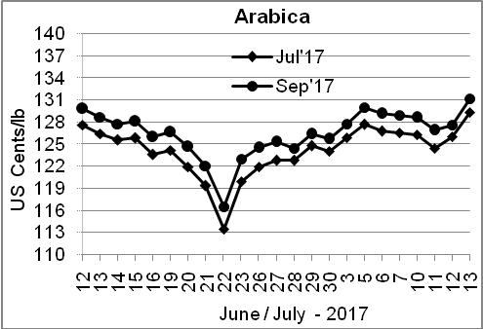
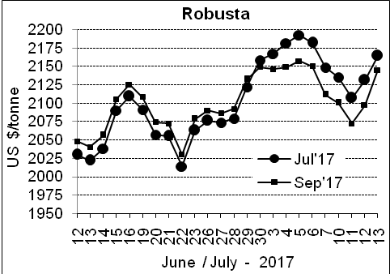

Market Analysis
ICE September arabica coffee futures settled up 3.6 cents at $1.312 per lb. September robusta coffee futures settled up $48 at $2,145 per tonne.

Differentials: | Ar. Plant. A | Ar.Chy.AB | Rob.Pmt.AB | Rob.Chy.AB
Differentials: | NY +15 to +18 | NY –9 to –13 | LIFFE +450 to +475 | LIFFE +25 to +50
2

ICTA Auction Prices Rs/Kg as on 22.06.2017
Grade | MNEB | AA | PB | A | AB | B | C | BBB
Arabica Plantation | --- | --- | --- | --- | --- | --- | --- | ---
Arabica Cherry | --- | 208.00 | --- | 206.00 | 156.00 | --- | 134.00 | 115.00
 | RKR | A | PB | AA | AB | B | C | BBB
Robusta Parchment | 161.00 | --- | 153.00 | --- | --- | --- | 140.00 | ---
Robusta Cherry | --- | --- | --- | --- | --- | --- | --- | ---

Raw Coffee Price (Karnataka) as on 13.07.2017 in Rs/50 kg
Ar.Pmt |  |  | Ar.Chy |  |  | Rob.Pmt |  |  | Rob.Chy
7525 | - | 7650 | 3950 | - | 4350 | 6250 | - | 6350 | 3250 | - | 3400

Export update: From 1st January 2017 to 13th July 2017 (in metric tonnes)
 | INDIAN COFFEE | Ar.Pmt | Ar.Chy | Rob.Pmt | Rob.Chy | Roasted seeds | R & G | Instant | Total
1 | Provisional exports (Indian coffee) | 24302 | 8466 | 18696 | 105324 | 21 | 154 | 27310 | 184274
2 | Provisional exports corresponding period last year | 30289 | 8089 | 17388 | 103632 | 23 | 122 | 13334 | 172877
3 | Provisional re-exports | 0 | 14 | 40 | 0 | 0 | 0 | 29757 | 29810
4 | Provisional re-exports corresponding period last year | 0 | 0 | 0 | 0 | 0 | 48 | 43129 | 43176
5 | Total provisional exports (1+3) | 24302 | 8479 | 18735 | 105324 | 21 | 154 | 57067 | 214084
6 | Total provisional exports corresponding period last year (2+4) | 30289 | 8089 | 17388 | 103632 | 23 | 169 | 56463 | 216054

Disclaimer: The Board neither guarantees the accuracy of the information nor accept any liability whatsoever for any direct or consequential loss arising from the use of this report

