COFFEE BOARD: BENGALURU
Daily Coffee Market Report Monday, July 17, 2017

Futures Prices 14.07.2017
ICE (New York)- Arabica- US cents / lb |  |  | LIFFE(London) – Robusta -US $ / tonne and cents / lb in brackets (10 MT contract)
Month | Price | Prev. Price | Month | Price | Prev. Price
July – 2017 | 131.70 | 129.35 | July – 2017 | 2165 (98.20) | 2164 (98.16)
Sep – 2017 | 133.70 | 131.20 | Sep – 2017 | 2146 (97.34) | 2145 (97.30)
Dec – 2017 | 137.30 | 134.80 | Nov – 2017 | 2130 (96.62) | 2123 (96.30)

ICO Group Indicator price on 13.07.2017 and previous price in brackets
Other Mild Arabica |  | Robusta |  |  | Exchange Rate Rs/ US $
US Cents/lb | Rs/kg | US Cents/lb | Rs/kg
148.35 (144.84) | 210.79 (205.77) | 105.41 (103.41) | 149.77 (146.91) |  | 64.45

Futures Price Trend
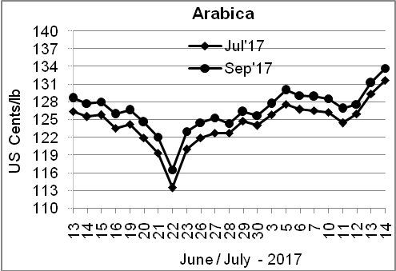
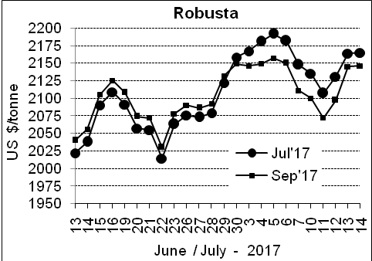

Market Analysis
ICE September arabica coffee futures settled up 2.5 cents, or 1.9 percent, at $1.337 per lb after hitting $1.3405, its highest since May 31. September robusta coffee futures settled up $1, or 0.1 percent, at $2,146 per tonne.

Differentials: | Ar. Plant. A | Ar.Chy.AB | Rob.Pmt.AB | Rob.Chy.AB
Differentials: | NY +15 to +18 | NY –9 to –13 | LIFFE +450 to +475 | LIFFE +25 to +50
2

ICTA Auction Prices Rs/Kg as on 22.06.2017
Grade | MNEB | AA | PB | A | AB | B | C | BBB
Arabica Plantation | --- | --- | --- | --- | --- | --- | --- | ---
Arabica Cherry | --- | 208.00 | --- | 206.00 | 156.00 | --- | 134.00 | 115.00
 | RKR | A | PB | AA | AB | B | C | BBB
Robusta Parchment | 161.00 | --- | 153.00 | --- | --- | --- | 140.00 | ---
Robusta Cherry | --- | --- | --- | --- | --- | --- | --- | ---

Raw Coffee Price (Karnataka) as on 13.07.2017 in Rs/50 kg
Ar.Pmt |  |  | Ar.Chy |  |  | Rob.Pmt |  |  | Rob.Chy
7525 | - | 7650 | 3950 | - | 4350 | 6250 | - | 6350 | 3250 | - | 3400

Export update: From 1st January 2017 to 14th July 2017 (in metric tonnes)
 | INDIAN COFFEE | Ar.Pmt | Ar.Chy | Rob.Pmt | Rob.Chy | Roasted seeds | R & G | Instant | Total
1 | Provisional exports (Indian coffee) | 24380 | 8466 | 18735 | 105875 | 21 | 155 | 27480 | 185112
2 | Provisional exports corresponding period last year | 30461 | 8159 | 17407 | 104370 | 23 | 122 | 13675 | 174218
3 | Provisional re-exports | 0 | 14 | 40 | 0 | 0 | 0 | 30051 | 30104
4 | Provisional re-exports corresponding period last year | 0 | 0 | 0 | 0 | 0 | 48 | 43547 | 43594
5 | Total provisional exports (1+3) | 24380 | 8480 | 18775 | 105875 | 21 | 155 | 57531 | 215217
6 | Total provisional exports corresponding period last year (2+4) | 30461 | 8159 | 17407 | 104370 | 23 | 170 | 57221 | 217812

Disclaimer: The Board neither guarantees the accuracy of the information nor accept any liability whatsoever for any direct or consequential loss arising from the use of this report

