Shot Hole Borer, an emerging pest of robusta coffee
In recent years, high incidence of Shot Hole Borer (SHB), Xylosandrus compactus Eichhoff (Coleoptera: Scolytidae) is noticed in robusta growing areas of South India and also in juvenile arabica holdings. Earlier it was considered as pest of minor importance. Nevertheless, off late the pest flare ups are noticed in almost all the robusta growing areas. This might be because of the changing climate and also due to some of the innovative agronomic practices adopted by the growers like drip irrigation coupled with fertigation. Generally the drip irrigation and fertigation results in luxurious growth of the bushes, thereby vulnerable to SHB attack. Because of these reasons shot hole borer is currently being considered as pest of concern in all coffee growing areas.
The adult beetles of SHB are brown to black in colour with a short, sub-cylindrical body. The newly emerged adults are light brown and turns shiny black in two to three days. The adult females are larger in size than the males and the size ranges between 1.5 to 1.8mm. Whereas, males are dull in color with a size of 0.8 to 1mm. Female beetles usually infests the green succulent branches both suckers and lateral branches/twigs. In certain cases the main stems also attacked in young plants. After entering inside the twig through the shot hole made on the lower side of the twig/ branches, usually between the intermodal regions, the female beetle makes a longitudinal tunnel inside the twig/ branches. Always the female beetles carries the ambrosia fungus from the infested twig to the healthy twig and allows it to grow in the new tunnel. After the development of the fungus colony inside the twig, SHB lays around 50 eggs in the tunnel in groups of around 5 to 8 eggs. These eggs hatch in to larva within 2-3 days and the hatched larvae will feed on the ambrosia fungus. Thus the survival of the SHB always related to the establishment of Ambrosia fungus. The larval stage lasts for 13 to 21 days, and the pupal stage for about 11 days. Oviposition to adult emergence takes 4 to 5 weeks. All the life stages of the pest can be seen in the same tunnel during the peak incidence period. The incidence is generally low before the onset of south- west monsoon, gradually reaches its peak during September to January and then declines during the dry period. The pest build up is high in densely shaded areas as shaded conditions favors the better establishment of the ambrosia fungus.
Symptoms and Nature of Damage
- Withered or dried branches/twigs with shot-holes on the coffee plants indicate the presence of the pest.
- The affected branches/twigs with SHB dries up fast due to the discontinuity in the flow of sap.
- The infested twig gradually turns black, and leaves above the point of attack drop off prematurely.
- The tip of the branches/twigs wilt, droop and dry. Withering is faster in young branches and relatively slow in older twigs/ branches.
- Severe infestation of SHB results in the loss of considerable number of productive branches. The loss is pronounced in young plants because loss of primaries affects the growth of young plants and the canopy development.
Management
For the effective management of SHB, the timely operations towards integrated management like cultural and judicious use of pesticides are inevitable. Early detection of SHB infestation and removal of the infested branches will help in reduce the inoculum of beetles and therefore, also spread of the pest. The incidence of shot hole borer could be effectively managed by adopting the following measures.
1. Prune the affected twigs 2.5 to 7 cm below the point of shot hole and burn immediately. This operation should commence from September onwards, as soon as the first symptom of attack like drooping of leaves is noticed and continued as a routine cultural operation as season progress.
2. During the dry period, the pest prefers to breed in suckers, hence timely removal of suckers after the blossom showers helps in minimizing the inoculum.
3. Maintain optimum shade and provide good drainage in the estate.
4. If the pest incidence level is still high, application of systemic fungicide Propiconazole 20 EC at the rate of 180ml in 200 l water. The fungicide should sprayed during August and September on the infested branches.
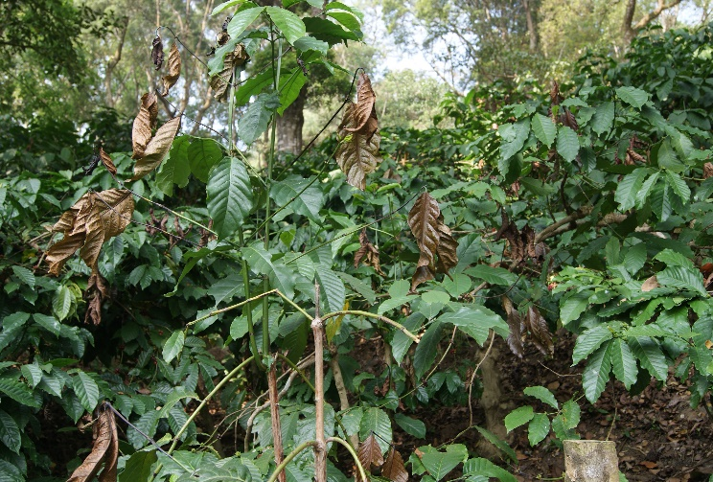
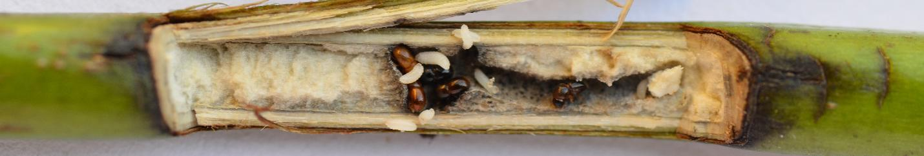
5. Indiscriminate application of nitrogen fertilizers in excess to the recommended doses favors the vegetative growth, which indirectly helps for pest build up. Hence, care should be taken for rationale use of fertilizer.
Fig. 3. Stages of SHB inside the tunnel with Ambrosia fungus
Fig. 2. Boring of SHB
Fig. 1. View of SHB infestation in filed

