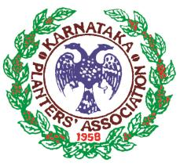
THE KARNATAKA PLANTERS’ ASSOCIATION
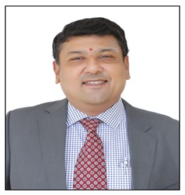
Mr. S. Appadurai
Chairman
NEWS LETTER – 2

Dear Members,
I wish the Best of Health to our Members to Stay Healthy and Safe!

I am pleased to circulate my second News Letter. This is to further brief you about the various events and developments that have taken place on various fronts related to the Association and the Plantation Sector since my News Letter of 16th March, 2021.

1. Budget General Meeting held on 22nd March 2021:

The 63rd Budget General Meeting of the Association was successfully held on 22nd March 2021 at the Munzerabad Club, Sakleshpur. About 32 members had attended. The Budget Proposals were passed at the meeting after discussion.

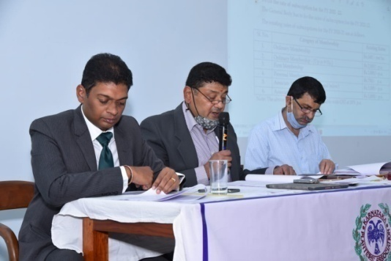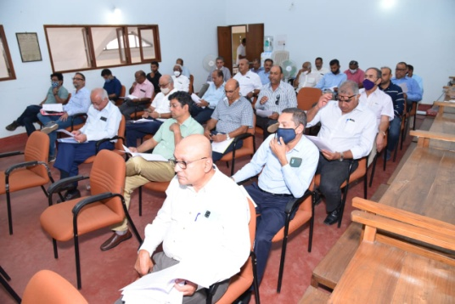
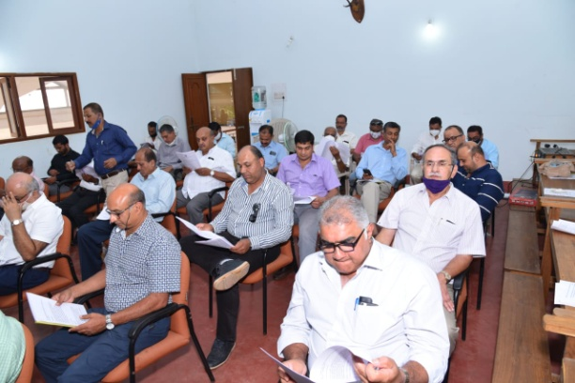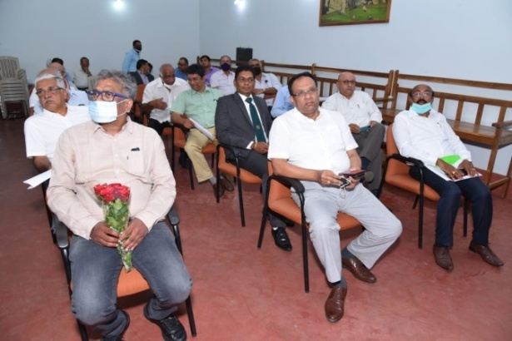

2. Meeting with Sri. D.V. Sadananda Gowda, Hon’ble Minister for Chemicals & Fertilizers, GOI on 27th March 2021.

I, Vice-Chairman Mr. N. Ramanathan, EC Members, Mr. Jeffry Rebello and Mr. Arvind Rao had met Sri. D.V. Sadananda Gowda, Hon’ble Minister for Chemicals & Fertilizers, Government of India on 27th March, 2021 at Bangalore and had submitted a Memorandum to follow up on the Memorandum sent to him on 9th February 2021 on reducing maximum limit for fertilizers and the following other issues.

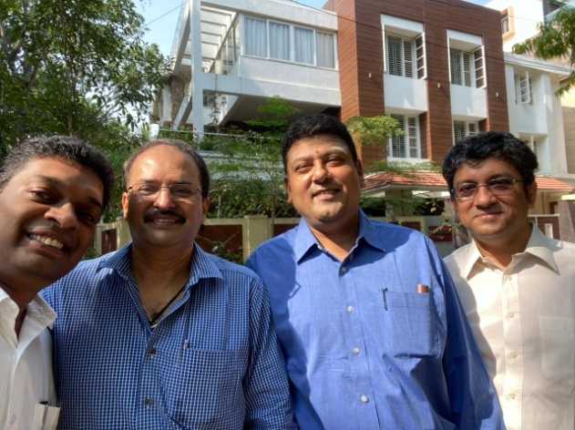

i). The Department of Fertilizers, GOI had reduced the maximum limit for purchase of subsidized fertilizers to 200 Bags under the notification dated 21st January 2021. KPA had written to the Hon’ble Minister on 19-2-2021 not to fix any limit for purchase of subsidized fertilizers who submit ID proof like Aadhaar Card, Biometrics, Kishan credit card, Voters ID, etc.

Later under the notification dated 24th March 2021, the maximum limit of 200 bags was increased to 1,200 Bags.

ii). Amend the Income Tax Rules 1962 to delete words in Rule 7B (1) “sale of coffee grown and cured by the seller”. By removing Rule 7B(1), a large number of Coffee Growers can cure their coffee and sell to get a better remunerative price for their produce fulfilling GoI objective of doubling Farmers income by the year 2022-23.

iii). The GOI had announced the RODTEP Scheme from 1st January 2021.To implement the scheme immediately and announce the rates suggested by KPA.

Thereafter the Ministry of Commerce & Industry published the guidelines and rates of the RODTEP export incentive scheme on 17th August 2021. The rate for Coffee, Tea, Pepper and Cardamom was fixed at 1% which comes to Rs. 1 for 1 Kg., 1.7% for export of Bulk Tea and 1.4% for export of Black Tea. The incentive rate was reduced from 3% which was earlier 5%. UPASI, KPA and Coffee Exporters Association had requested 9.8% rate for Coffee. The Plantation sector was disappointed with the rates announced.

The Ministry of Commerce & Industry had suddenly stopped accepting scripts under the MEIS scheme from 1st April 2020 putting Coffee exporters to great hardship. It was requested to implement the MEIS scheme from 1-4-2020 till 31-12-2020.

iv). Exempt or Reduce Customs Duty on Plantation Machinery, equipment, fertilizers, pesticides, herbicides, effluent treatment plants, chemicals and plant material imported or facilitate collaboration with foreign companies to manufacture them domestically under the “Make in India” policy of the GOI suitable to Indian conditions.

3. Consultative meeting of Coffee Board on revision of Coffee-Chicory FSSAI Labelling Standards held on 12th April 2021.

KPA was invited by the Coffee Board for the consultative meetingof stake holders on 12th April 2021 on revision of Coffee-Chicory FSSAI labelling sstandards. I had attended the meeting along with Mr. Jeffry Rebello and the Secretary Anil Savur.

Later the following inputs were sent by KPA to Dr. K. Basavaraj, Head, Coffee Quality Division Coffee Board on 29th April 2021.

i). To label 100% pure Coffee without Chicory as “Roasted & Ground 100% Pure Coffee and Soluble /Instant 100% Pure Coffee.”

ii). In the alternative, Maximum Chicory content in Coffee should be limited to 30% and 70% Coffee. Under FSSAI, Maximum limit for Chicory is 49%.

iii). If more than 30% chicory is mixed with Coffee, subject to the Maximum of 49% permissible under FSSAI to support Coffee Board proposal to lable “Chicory added Coffee” ________ % Coffee: ______ % Chicory to inform exact Coffee: chicory mix.

4. Webinar on “Interactive Session on Prospects of Top Grafting in Coffee 18-05-2021.

The Scientific Committee of the KPA in co-ordination with the CCRI, Coffee Board had successfully organized a Webinar on "Interactive Session on Prospects of Top Grafting in Coffee” on 18th May, 2021 exclusively for KPA members. Dr. V.B. Suresh Kumar, Divisional Head, Plant Breeding & Genetics, CCRI had made the video presentationin addition a presentation was made by Mr. Pavan Nanjappa, a Planter from Coorg. The presentations explained Top Grafting in Coffee with a Video Demo. 44 KPA members had attended the Webinar. In the interaction which followed Members asked and clarified many questions on Top Grafting in Coffee.

5. Memorandums to MESCOM & CESC to provide Three Phase Uninterrupted Power Supply to IP Sets used by Coffee Growers in Chikmagalur, Kodagu, Hassan and Chamarajanagar Districts for Coffee Blossom and Backing Irrigation.

We had sent a Memorandum to the Managing Directors of MESCOM and CESC and their Officers in Chikmagalur, Kodagu, Hassan Districts and Sakleshpur circle to provide Three Phase Uninterrupted Power Supply to the Coffee Plantations to irrigate
Robusta Coffee plantations for Blossom and Backing using IP sets for getting good coffee crop to lead their livelihood.

Three phase power supply to Coffee Plantation areas in Chikmagalur, Kodagu, Hassan and Chamarajanagar Districts is very poor and there are frequent power cuts, power disruptions, High and low voltage fluctuations.

The coffee growers pay minimum charges throughout the year to keep their IP sets running so that they can use them at this crucial time for irrigation.

Generating Power using captive diesel generators is expensive due to the high cost of diesel.

6. Coffee Board virual meeting on 14th May 2021 on issues, difficulties and interventions required due to COVID 19 pandemic.

I, Vice Chairman Mr. N. Ramanathan, Mr. Jeffry Rebello and the Secretary Mr. Anil Savur had attended the important virtual interactive meeting. Difficulties faced by Coffee Growers due to COVID 19 pandemic were brought to the attention of the Secretary Coffee Board Dr. K.G. Jagadeesha and requested his intervention to find a solution to the following issues.

i). To take up with the District Administrations of the plantation districts to extend time to purchase fertilizers, spray and other agricultural inputs, allow to engage outside labour as it is not allowed subject to following of Covid 19 SOP.

ii). Open plantation services and repair workshops for service and repair of plantation machinery and equipments.

iii). Allow free movement of Coffee growers, labour and employees as growers have coffee plantations in Chikmagalur, Hassan, Kodagu and Chamarajanagar districts subject to following Covid 19 SOP as inter district travelling is restricted.

iv). Request Railways to run special trains from the North East to Bangalore, Mysore, Hassan, Sakleshpur and Chikmagalur for Migrant workers to travel from their native places to the plantations as there is acute scarcity of labour.

v). Request the district administrations of the Plantation districts to provide adequate Covid Testing Labs, Vaccines, hold special camps in the Estates to test and treat cases.

vi). To request SLBC to allow Banks to function from 10.00 am to 2 .00 pm.

vii). Request Ministry of finance to exempt plantations of TDS at 2% up to 1 Crore and 5% above 1 Crore on cash withdrawals from Bank accounts; As Coffee plantations employ large labour force and they require large cash for payment of wages to workers.

viii). The Circular dated 24th March 2021 as revised the maximum limit for sale of subsidized fertilizers from 200 Bags to 1200 Bags Per Plantation Per month for Plantations. To fine tune the software of the POS machines in line with the 24th March 2021 circular and not to insist for GST for growers as most growers do not have GST.

ix). Request the department of Fertilizers to retain existing MOP prices and not increase as plantations are put to great hardship due to financial crisis and Covid 19.

x). To release long pending replanting subsidy of eligible Coffee growers in view of the difficulties faced by growers due to Covid 19.

xi). Request Ministry for Commerce & Industry to approve next plan of Coffee Board for Coffee Growers and Exporters inthe period from 2021-22 to 2025-26 and to update the components of the plan suited to the Covid 19 situation.

xii). Request GOI to extended the PMGKY EPF Scheme in the FY 2021 which was in force till August 2020 due to lockdown /Covid 19; as Covid 19 second wave is more severe than the first wave.

xiii). Request GOI and EPFO to extend the date for payment of provident Fund as Banks are working from 10.00 am to 1.00 pm and post and courier services are delayed.

xiv). To include coffee under Production linked incentive scheme to make Indian manufacturers globally competitive, attract investment in cutting-edge technology areas, ensure efficiencies; enhance exports and to make India integral part of the global supply chain; As 80% of coffee grown in India is exported and FDI is allowed in Coffee.

xv). To write to the Ministry for Commerce and Industry and Department of Commerce to announce the rates and details of the RoDTEP Scheme at the earliest which has come into effect from 1st January 2021.
xvi). Co-ordinate with the phyto-sanitary authority to issue soft copy of the phytosanitary certificate to enable exporters to download or sendby email as exporter Banks need physical copies to release the working capital as during lockdown it is impossible to submit physical copies to the Banks.

xvii). To discuss with SLBC to consider 70% of the payment outstanding to exporters under the erstwhile MEIS scheme be given as working capital.

Later the Secretary, Coffee Board Dr. K.G. Jagadeesha wrote to the Deputy Commissioners of the Coffee Plantation districts and other authorities on the above issues. The Guidelines in the districts were slightly modified allowing purchases from 6.00 am to 10.00 am and Banks were allowed to function from 10.00 am to 1.00 pm. KPA is thankful to the Secretary Coffee Board for his ever help and assistance.

7. Letter to the DCs of three Plantation Districts during Lockdown on 26-05-2021.

The KPA had written to the Deputy Commissioners of Chikmagalur, Kodagu, Hassan and Chamarajanagar Districts on 26th and 28th May 2021 bringing to their attention the difficulties faced by the plantation growers due to lockdown under Covid 19 requesting to allow vehicles of plantation owners, their Managers, staff and Labourers to visit nearby Towns, Villages, Taluk and District headquarters to buy plantation inputs like fertilizers and Chemicals, visit Banks to draw cash for disbursement of wages to workers, buy groceries, fruits, vegetables, essential commodities and refill ATMs regularly. Emails were also sent on 20th May 2021 to undertake more Covid 19 tests in the plantation areas, to owners and their employees, supply enough vaccinations, hold special camps at the estates to test for Covid 19, supply sufficient quantities of vaccines to vaccinate plantation owners and their employees.

8. Coffee Board Virtual Meeting on 11th June 2021 to discuss fertilizer issues.
The Coffee Board had held a virtual meeting with the Coffee Grower Associations to get the inputs on maximum limit on purchase of subsidized Fertilizers and other fertilizer issues to take up with the Department of Fertilizers (DOF). The meeting discussed in detail the fertilizer issues.

We informed the software of the POS machines has to be fine tuned in accordance with the 24th March 2021 circular of DOF to get the benefit of 1200 Bags fertilizers to Plantations as the POS machines ask for GST number. I informed KPA had met the Minister for Chemicals and fertilizers Sri Sadananda Gowda on 9th May 2021 and had discussed the fertilizer issues. GST is made mandatory to check misuse of subsidized fertilizers.

Secretary Coffee Board Dr. K.G. Jagadeesha informed the Coffee Board had written and co-ordinated with the DOF and GOK on fixing maximum limit for fertilizers. Based on consensus, the Coffee Board decided to recommend to the Department of Fertilizers to fix maximum limit of fertilizers on Annual Basis as follows:

i). 600 Bags pa to individual plantation owners on production of Aadhaar.
ii).More than 600 Bags pa on production of Aadhaar and land records. iii). 14,400 Bags pa to Companies on the basis of GST.
iv). Companies requiring fertilizers more than 14,400 pa on the basis of GST and production of land records.

On behalf of KPA, I and our Secretary Mr. Anil Savur had participated. On behalf of UPASI, President Mr. Prashant Bhansali and Vice President Mr. Sanjay Cherian, Chairman UPASI Coffee Committee and our EC Member Mr. Jeffry Rebello and UPASI and KPA EC member Mr. M.B. Ganapathy and other Coffee growers Associations from Karnataka, Tamil Nadu and Kerala had participated.

9. 17th Edition of Golden Leaf India (TGLIA) Tea Award 2021. :

Our Member M/s. Devon Plantations won the 17th Edition of Golden Leaf India Tea Award (TGLIA) under “Others” category in CTC Leaf and CTC Dust.

10. IBSA Virtual Coffee Festival 2021 on August 4 and 5 2021:

A two day virtual India, Brazil & South Africa (IBSA) Coffee Festival was held on 4th and 5th August 2021 from 4.0pm t 8.00 pm Indian Time. Registration for the festival was free. About 3000 delegates from 20 countries had attended the Festival. Executive Committee and KPA Members had registered for the Festival. Presentations on the following useful topics were made by resource persons.

i). Global Coffee Session, Impact of Covid 19 and opportunities for IBSA: Mr. Josse
Sette, Executive Director, ICO.
ii). Brazil Coffee Industry.
iii). Coffee Scenario in India by Dr. P.G. Chengappa.
iv). Climate Change, Impact on Coffee Sector & Mitigation strategies.
v). Coffees of India, Shade grown and sustainable – By Sunalini Menon.
vi). Coffee Consumption Strategies in Brazil – By Carlos Brando.
vii). India’s domestic market – Emerging Trends By Vikram Khurana.

From India, Mr. Ramesh Rajah, President, Coffee Exporters Association, Mr. Anil Kumar Bhandari, President India Coffee Trust, and Mr. I.B.Bopanna, Coffee Grower from Coorg both KPA Members moderated the sessions.

The Coffee Festival was an eye opener to participants from India on how Brazil achieves high production, and high domestic consumption well known in the International Coffee Industry and importance given by Brazil to Coffee quality by presentations made.

11. Other Webinars:

The Following Webinars were held for KPA Members.

1. “Blister Blight Management” in Tea by UPASI TRF on 1st July 2021.
2. "Management on Blister Blight and Grey Blight Diseases in Tea" on 27th July 2021.
3. “MSME exports from Karnataka, Opportunities & Challenges” by Federation of
Indian Export Organization.
4. "Varietal Wealth of Black Pepper" by ICAR on 17th June 2021.

12. KPA Sports Club – Sports Events on 10th April, 2021.

The KPA spots Committee / KPA Sports Club had organized a Cricket and Shooting Tournament on 10th April, 2021 at Chikmagalur. About 25 members had participated in the cricket Tournament and Shooting Tournaments.

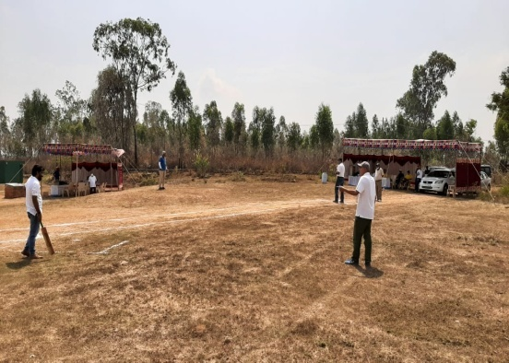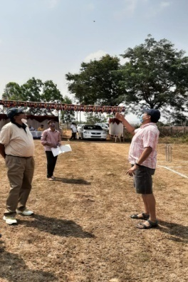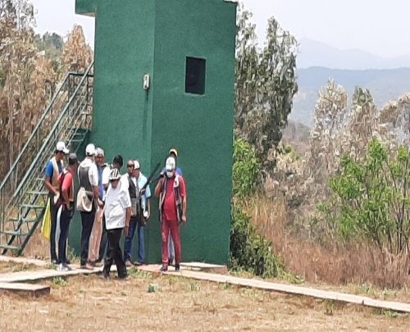

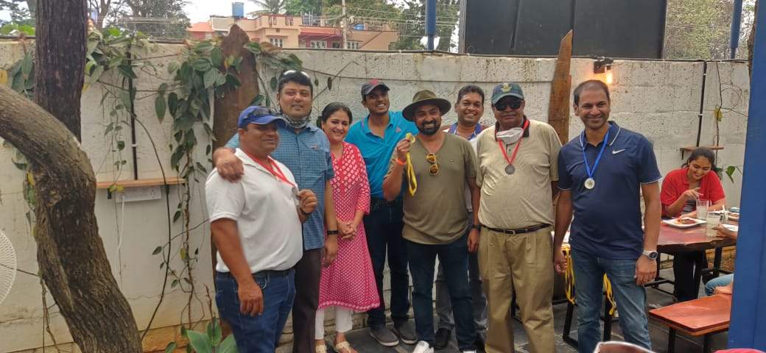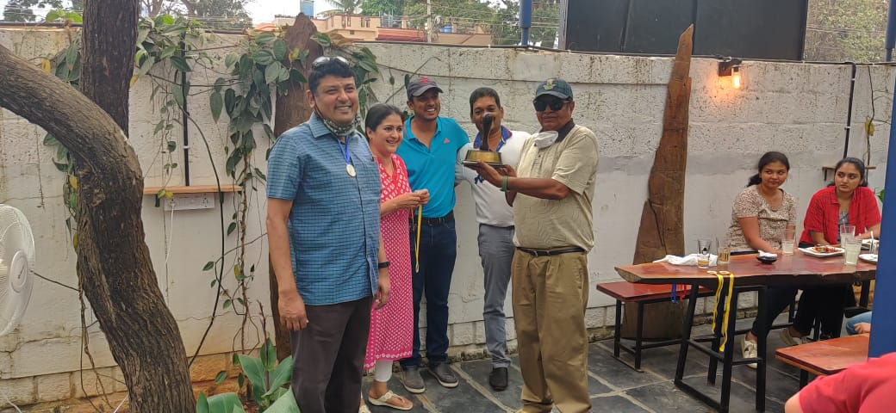

A Prize distribution ceremony was held at the “Take-5”, Planters’ Court, Chikmagalur, followed by fellowship and lunch which was liked and appreciated by the members.

KPA Sports Club Virtual Run: KPA Sports Club ad also held a Virtual Run for Sports Club and KPA Members. Mr. Ranveer N. Gurjer came first clocking 15.53 Mins and Mr. Krishant Chowdlu second clocking 24.20 Mins in the fastest 5 Kms run. Mr. Ranveer N. Gurjer came first in the 30 Min elevation challenge with 155 Meters.

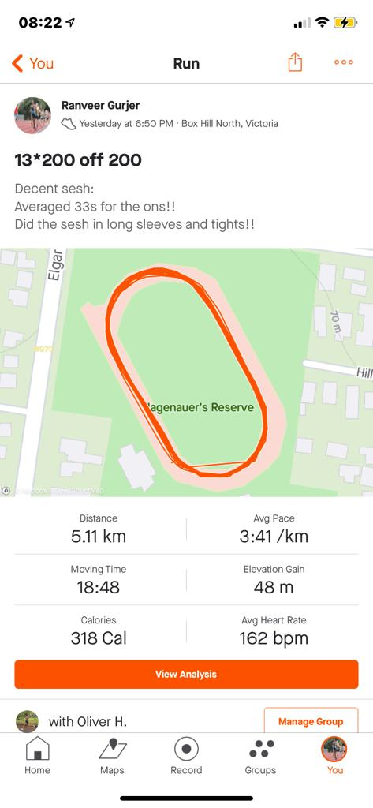
KPA Sports Club Virtual run held in July & August 2021.
I. Fastest 5km 1st Place: Ranveer: 17.53 min. 2nd Place: Krishanth: 24.20 min.
II. 30min Elevation challenge 1st Place: Ranveer Gurjer: 155 metres.
III. Most kilometers/steps for the two months 1st Place: Ranveer Gurjer: Over 150 kms in 2 months.

13. KPA Sub-Committee Meetings.

i) The Meeting of the Sports Committee was held on 10th February and 28th June, 2021.
ii) The Meeting of the Tea Committee was held on 2nd August, 2021.
iii) The Scientific Committee Meeting was held on 2nd September, 2021.

14. KPA Circulars:

The following circulars were sent by the KPA office by e-mail and post. I request Members to go through and note the same.
- Variable Dearness Allowance to Staff from 01-04-2021 to 30-06-2021.
- Precautionary measures to be taken by Plantations against Covid 19 regarding Inter State and Inter District Migrant workers if engaged by Plantations in Chikmagalur, Kodagu, Hassan and Chamarajanagar Districts.
- Notification on Employees’ Provident Fund and Miscellaneous Provisions Act 1952, Minimum and Maximum assurance benefit under Employees’ Deposit - Linked Insurance Scheme.
- Advisory Guidelines for the welfare of migrant workers returning to their destination Districts & States.
- Last date extended up to 1st September, 2021 for sending of Aadhar with UAN.
- Vaccination of Workers, working in Plantations.
- Variable Dearness Allowance to Staff from 01-07-2021 to 30-09-2021.
- Vaccination requirement on Covid-19 by Member Estates.
- Pradhana Mantri Matru Vandana Yojana (PMMVY) to eligible Interstate Migrant pregnant and lactating women workers working in Coffee Plantations.
- Relief to Coffee Growers affected by Heavy Rains and Floods in 2020 in Karnataka by Banks.
- Webinar on “Interactive Session on Prospects of Top Grafting in Coffee” exclusively for KPA Members.
- Pre-monsoon Advisory from CCRI on Plant Protection in Coffee Plantations.
- Webinar on Pre-Monsoon Disease Management Measures in Coffee on 11th June, 2021.
- Webinar by ICAR-Indian Institute of Spices Research Regional Station, Appangala on "Varietal Wealth of Black Pepper" on 17th June 2021.
- Pre-Monsoon Disease Management Measures in Coffee and Interactive session on prospects of top grafting in coffee.
- Webinar on “Planting and aftercare in Coffee” on 13th August, 2021.
- Advisory on Coffee for the Month of August received from the Head - Research & Development, TATA Coffee Ltd.,

With Best Wishes & Warm Regards,

Yours sincerely,

Mr. S. APPADURAI
Chairman
Date: 28-08-2021

